**THE ANALYSIS OF WATER CONSUMPTION IN TYUMEN**

by

Vladimir Kibukevich

Darya Semenova

Evgeniia Kolosova

Introductory Econometrics using Gretl

University of Tyumen

2021

**Introduction**

Intensification of water consumption is an important environmental issue nowadays. Such international organizations as the UNFAO and the United Nations World Food Program have stated that today water shortage is an actual global problem, and without any intervention, water scarcity issues will not be solved (World Health Organization and UN-Water 2014). Moreover, for water is a necessity for all humans, it was stated that the water problem has potential to become the reason for future political tensions if it would not be solved on the international level (Starr 1991). Additionally, there is the following pattern: with population growth, the demand for freshwater is also growing.

Researchers and politicians suggest different measures to tackle the water consumption issue. Officials mostly consider a price as a tool for solving water consumption issue. So, European Council called states to provide “adequate incentives for users to use water resources efficiently”. It was established that water price should cover all deleterious consequences of water consumption “taking account of the polluter pays principle” (European Council 2000). On the other hand, a branch of researchers argues that there is another way of solving the issue. They consider non-financial incentives, such as nudges, feedbacks and some others as efficient tools for the regulation of water consumption (Richetin et al. 2014; Kahneman 2013).

Actually, applications of behavioural economics are well-spared means to influence the behaviours of agents in various ways. For instance, both the US and UK have already launched teams in order to help policymakers upgrade the policy by using insight from behavioural sciences (a.k.a. “The behavioural insight team”). Officials started encouraging citizens to make the decision that improves not only their wellbeing but also common welfare. So, they used nudges in the form of text messages to tackle the issue of unpaid fines, and it worked (Haynes et al. 2013). In general, insights from behavioural sciences are widely used to affect the consumption of energy, alcohol, tobacco etc.

Behavioural insights contribute to the solving of water consumption issue. Actually, the purpose of incentives and nudges is to affect the behaviour of consumers in a specific way. They increase awareness among consumers of their water consumption. The water consumption is indirect by nature. People consume water, not paying attention to how many of it they pour. To understand the exact amount of water they used, consumers need to read the water meter before and after they tap on or run a dishwasher. Each time reading the water meter and then counting the price of consumed water is a too complicated and meaningless process for such routine procedures. Especially if we take into account that the cost of water is relatively low. Such type of behaviour labelled as inattentiveness, because consumers have a biased understanding regarding the amount of water they consumed as well as its cost (Reis 2006).

Doing the research in Tyumen, Russia, is an investigation of the water issue in a unique area for several reasons. First, the water supply network in Tyumen has a long history when people were paying not for each unit of volume of water they had consumed, but for the number of people in the household. There was not any dependence between the amount of water a household consumed and the monetary amount that the household had to pay. It was only 7 years ago that the unit cost system was introduced in Tyumen by Gorvodocanal. It leads me to believe that the culture of water usage in Tyumen differs from water consumption culture in countries where a direct connection between the consumed amount of water and household expenses for water has been taken for granted for a long time. Second, according to the World Health Organization, Russia is second in the world for global water resources and, consequently, most of the Russian regions have not ever experienced water scarcity (UNESCO 2003). The Tyumen region is no exception, and water prices in Tyumen are relatively low. Third, the type of research on water issue that considers behavioural, financial and other variables is new not only in Tyumen but even in Russian. Actually, there is a branch of studies that researches the Russian water supply system, but mostly they examine the technical side of it (Danilov-Danil’yan and Losev 2006). So, empirical estimation of urban water demand in Tyumen is an investigation of the culture of water consumption in a region where there is no water shortage, and water demand elasticity is immensely low.

**Literature review**

In terms of research on water consumption, different studies outline different variables that affect water consumption (Graymore and Wallis 2010; Arbués and Villanúa 2006; Victor Corral-Verdugo, Bechtel, and Fraijo-Sing 2003; Víctor Corral-Verdugo and Frías-Armenta 2006; Jorgensen et al. 2014; Harland, Staats, and Wilke 1999). In general, they can be divided into three branches: financial, structural and behavioural. Different studies choose various groups of a variable to find the main predictors of households’ water consumption.

Almost all researchers in the field agree that price variable is an important predictor of water consumption even though it varies from study to study (Martins and Fortunato 2007; Mazzanti and Montini 2005; Nauges and Thomas 2003; Schleich and Hillenbrand 2009). Particularly, Schleich et al. l in their work provide a descriptive table with different measurement of elasticities of water demand based on findings of scholars from different countries (Schleich and Hillenbrand 2009). Moreover, price is considered by the European Council as an efficient tool for regulation of water consumption(European Council 2000).

On the other hand, some researchers doubt regarding price as an appropriate tool for tackling water consumption issues because water is a basic human need and, therefore, it must be available to everybody. For example, Chessman et al. argue that a general increase in the cost of water restricts access to a vital resource for the part of the population who live below the poverty line (Cheesman, Bennett, and Son 2008). Additionally, it is complicated to implement a water policy of “reasonable” use of water because of the low elasticity of water demand in certain areas. As Arbues et al. argue, “users’ sensitivity to changes in price is different depending on the number of household members” and their response to increases or decreases in water tariffs is feeble (Ojeda-Benítez, Vega, and Marquez-Montenegro 2008; Schleich and Hillenbrand 2009).

Set of structural variables that are used to predict water consumption consist of such variables as household size (Arbués and Villanúa 2006), an income of household’s members (Schleich and Hillenbrand 2009), employment status (Cheesman, Bennett, and Son 2008), age composition of the households (Arbués, Villanúa, and Barberán 2010). In most instances, income positively correlates with water consumption (Schleich and Hillenbrand 2009; Dandy, Nguyen, and Davies 1997), as does employment status (Lim et al. 2012). It was proved that climate also affects the rate of households’ water consumption, especially the percentage of hot days in the period (Arbués, Villanúa, and Barberán 2010; Schleich and Hillenbrand 2009).

In addition to the determinants mentioned above of water consumption, there is a branch of behavioural determinants. A few studies indicate the relationship between water consumption and personal, attitudinal variables. They found such determinants as personal normative beliefs (Víctor Corral-Verdugo and Frías-Armenta 2006) and individual motivations (Jorgensen et al. 2014). For example, Ferraro et al. concluded that a family members’ education and pro-environmental behaviour of the family are positively correlated (Ferraro, Miranda, and Price 2011).

Among behavioural variables, there is a specific group, nudges. Nudges encourage consumers to behave in a pro-environmental way: to reduce power consumption (Gleerup et al. 2010), to conserve water (Ferraro, Miranda, and Price 2011; Syme, Nancarrow, and Seligman 2000), to reduce gasoline consumption (West and Williams 2005). So Gleerup et al. demonstrated that nudges, supplying mailing and SMS-feedback to households, produce a reduction of power consumption. They argue that providing information to individuals affects their behavioural so that consumption decisions can be made in a different way (Gleerup et al. 2010). While Matsukawa provides feedback in another way. He installed continuous displays in residence to give information about the power consumption of a household (Matsukawa 2004).

Another type of nudge is descriptive norms. So, Ferraro et al. examined the usefulness of them. He found out that redaction of water consumption can be achieved by indicating the amount of water consumed by neighbours (Ferraro, Miranda, and Price 2011). While Aitken et al. demonstrated that people, households tend to adjust their water use based on the average consumption. They conducted the study in a different way. To reduce water consumption they “gave the consumption at that property for the past week along with the average consumption for a household of the same size as the recipient’s” while average consumption was artificially diminished by about 10% to create a larger number of households with the potential to be affected by the treatments (Aitken et al. 1994).

Beside feedback and descriptive norms, there are other nudges that are used to encourage people to pro-environmental behaviour. Such nudges are intervention text messages with different incentives contained inside of them. It was proved that self-interest, environmental protection, social responsibility are working incentives that affect consumers’ behaviour in a pro-environmental way (Bernedo, Ferraro, and Price 2014; Nolan et al. 2008). Also, another few studies investigated that narrowing the gap between abstract goals and the specific result of behavioural changes encourages people to reduce water use (Rabinovich et al. 2009; Lindenberg and Steg 2007). So Lindenberg et al. assert that a general normative goal such as acting pro-environmentally will influence behaviour when individuals know how to act in a specific situation.

Given the above points, the estimation of water demand elasticity and the water price variable effect on water consumption of households is the first step in search of incentives for reducing water consumption. Assessment of change in water consumption after using the nudges in the form of intervention text messages is a second step. The aim of my study is an estimation of the impact of various behavioural incentives on the method of water consumption. My initial hypothesis is that in cases where financial incentives are not effective, nudges could help with regulation of water usage. Moreover, water consumption of households can be relatively not efficient even when modest financial incentives (like price increases or tariffs) are present. To this end, I undertake an empirical estimation of household water demand in Tyumen, Russia, conduct an experiment and carry out a comparative assessment between households’ method of water consumption in Tyumen and other areas where similar studies have been completed. The result of my research can be used by water utility managers and environmental advocacy groups to implement more efficient demand management programs to encourage "reasonable" use of water by private consumers.

**WATER DEMAND MODEL**

My study's object is the water supply system in Tyumen and how individual consumers might be brought to reduce their water consumption. Considering water models provided by available empirical papers (Arbués, Villanúa, and Barberán 2010; Schleich and Hillenbrand 2009), I propose the following water demand model:

Nov20_it=f(С_it,〖tar〗_it,〖HD〗_it, 〖child〗_it, 〖olders〗_it,〖SQ〗_it,〖NM〗_it)

where Nov20_it≡ average quarterly water consumption in a quarter (t). Even though Tyumen's municipal regulation provided me with data containing monthly meter readings.

〖tar〗_it≡ a specific treatment that was used in time period t to change water consumption of a household i.

C_it≡ cost for one cubic meter of water. In Tyumen, the water tariff structure is not progressive. The municipal regulation establishes water prices bi-annually, and prices for all households are the same. Residential water consumers receive their water bill monthly. Their monthly expenses for water can be counted as V_it* C_it, where V_it is a consumed volume of water measured in cubic meters (m^3) and C_it is a price of water in rubles (₽).

〖HD〗_it≡ hot days. This variable indicates the percentage of days with an average temperature above the average temperature in each meter reading period. Weather data, the daily average temperature, was obtained from the Meteorological station of Roschino airport.

〖SQ〗_it≡ dwelling area. It is measured in square meters (m^2). The data was obtained from the State Property Register.

〖child〗_it≡ presence of a child / children under the age of 7 in the household. The variable Ch is a dummy variable, where 1 - there are children under 7 years old in the household, while 0 - there are no children under 7 years old in the household. The data was obtained from the State Property Register.

〖olders〗_it≡ the presence in the household of pensioners, elderly people over the age of 65. The variable Old_it is a dummy variable, where 1 - there are elderly people in the household over 65, while 0 - there are no pensioners in the household. The data was obtained from the State Property Register.

〖NM〗_it≡ household size or, in other words, the number of members in the household. Further, I transformed this into dummy variables to estimate how households of different sizes respond to different incentives. Since I divide household-dwellings into 5 groups, I have five dummy variables.

**Intuitive inferences: IMPACT OF THE HOUSEHOLD SIZE ON TOTAL WATER CONSUMPTION AND WATER CONSUMPTION PER CAPITA**

Two variables of size and water consumption are given in Table 1. They have a different type of relationship in regard to household size (See chart “Total consumption VS consumption per member”).

|  |  |  |  |
| --- | --- | --- | --- |
| **Table 1**  Size and Water Consumption | |  |  |
| Size of household | Total consumption | Per capita consumption | Change in per capita consumption |
| NM=1 | 7.478245 | 7.478245 | - |
| NM=2 | 10.25418 | 5.127089 | -2.351156 |
| NM=3 | 12.21395 | 4.071317 | -1.055772 |
| NM=4 | 15.42699 | 3.856749 | -0.214568 |
| NM>=5 | 17.16167 | 3.419519 | -0.424416 |

In terms of the water consumption per capita perspective, Table 1 clearly identifies a pattern: mostly, there is an inverse relationship between per capita water consumption and the number of household members. Economies of scale are observed here; while the number of members increases, the per capita consumption decreases, ranging from 7.478245 per day (NM=1) to 3.419519 per day (NM>=5) (See Table 1). The relationship between total water consumption and household size, in contrast, is direct. Each extra member in the household increases its consumption of water.

In my data set is noted the same pattern that Arbues et. al have discovered in their study of water consumption in Zaragoza, Spain (Arbues, Villanua, and Barberan, 2010). To explain the aforementioned dependence, they suggest a reasonable explanation, that “uses connected more to a set of indivisible basic forms of consumption allocated to common household uses than to the number of household residents” (Arbues, Villanua, and Barberan, 2010). Actually, there is a fixed amount of water that is consumed, regardless of household size, e.g. the amount of water to keep the dwelling clean at all times or amount of water to cook certain meal.

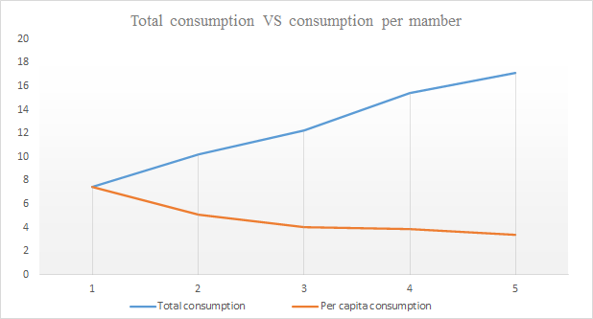

Water consumption is a complex process, so to begin with, let's consider cross-section data. The time period is November 2020. The basic model in this case is as follows:



**REGRESSION MODEL ESTIMATION**



**Модель 1: МНК, использованы наблюдения 1-711**

**Зависимая переменная: Nov20**

**Коэффициент Ст. ошибка t-статистика P-значение**

---------------------------------------------------------------

const 8.01463 3.45254 2.321 0.0206 **

SQ 0.0288409 0.0187462 1.538 0.1244

NM 1.95801 0.263986 7.417 3.45e-13 ***

child 3.15991 0.875896 3.608 0.0003 ***

olders −3.73033 0.795494 −4.689 3.29e-06 ***

tar −0.103149 0.103355 −0.9980 0.3186

Среднее зав. перемен 10.09077 Ст. откл. зав. перемен 8.747657

Сумма кв. остатков 45600.39 Ст. ошибка модели 8.042475

R-квадрат 0.160682 Испр. R-квадрат 0.154729

F(5, 705) 26.99348 Р-значение (F) 5.04e-25

Лог. правдоподобие −2488.100 Крит. Акаике 4988.201

Крит. Шварца 5015.601 Крит. Хеннана-Куинна 4998.785

Исключаем константу. Наибольшее р-значение получено для переменной 7 (tar)

We can conclude that only 3 variables out of 5 influence water consumption in November: the number of members in the household (NM), presence of a child / children under the age of 7 in the household (child), the presence in the household of pensioners, elderly people over the age of 65 (olders). Each additional member in the household increases consumption by 1.958 cubic meters (m^3). The presence of children under 7 years old in the household increases consumption by 3.159 cubic meters (m^3). The presence in the household of pensioners decreases water consumption by 3.730 cubic meters (m^3). R2 of the model is equal to 0.160. We conclude that the model explains only 16% of y variations (water consumption in November 2020).

**Hypothesis testing. Significance test (two-sided t-test)**

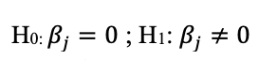

**If p-value < a we reject H0**

**ɑ = 5%**

· 0.1244 > ɑ ; accept H0

· 3.45e-13 < ɑ ; reject H0

· 0.0003 < ɑ ; reject H0

· 3.29e-06 < ɑ ; reject H0

· 0.3186 > ɑ ; accept H0

We can conclude that only 3 factors of 5 are statistically significant: the number of members in the household (NM), presence of a child / children under the age of 7 in the household (child), the presence in the household of pensioners, elderly people over the age of 65 (olders). Considering previous results, we can build a new model with only statistically significant predictors.



**Модель 1: МНК, использованы наблюдения 1-711**

**Зависимая переменная: Nov20**

**Коэффициент Ст. ошибка t-статистика P-значение**

---------------------------------------------------------------

const 6.10865 0.579063 10.55 2.91e-24 ***

NM 2.03129 0.259574 7.825 1.85e-14 ***

child 3.21900 0.875932 3.675 0.0003 ***

olders −3.75915 0.795910 −4.723 2.80e-06 ***

Среднее зав. перемен 10.09077 Ст. откл. зав. перемен 8.747657

Сумма кв. остатков 45807.59 Ст. ошибка модели 8.049316

R-квадрат 0.156868 Испр. R-квадрат 0.153290

F(3, 707) 43.84669 Р-значение (F) 5.40e-26

Лог. правдоподобие −2489.712 Крит. Акаике 4987.424

Крит. Шварца 5005.691 Крит. Хеннана-Куинна 4994.480

Exclusion of two statistically insignificant variables does not really change the result. R2 of the model now equals 0.1568.

**Multicollinearity using correlation analysis and variance inflation criterion   
(VIF)**

If explanatory variables are highly correlated then we have a multicollinearity problem. To solve this problem we should use 3 criterions.

**1 criterion: Correlation analysis**

Nov20 SQ NM child olders tar

1,0000 0,1318 0,3357 0,2531 -0,1409 -0,0294 Nov20

1,0000 0,2161 0,1203 -0,0093 0,0552 SQ

1,0000 0,3904 0,0779 0,0076 NM

1,0000 -0,0010 -0,0035 child

1,0000 -0,0023 olders

1,0000 tar

The relationship with the dependent variable is average for the NM component (0.3357), the relationship between NM and child is average (0.3904), and the relationship with the rest is weak. Here we do not see a strong correlation, which means that there is no signal for the existence of a multicollinearity problem.

**2 criterion: Condition number**

Belsley-Kuh-Welsch collinearity diagnostics:

variance proportions

lambda cond const SQ NM child olders tar

4,203 1,000 0,000 0,004 0,011 0,012 0,012 0,000

0,841 2,236 0,000 0,000 0,004 0,372 0,522 0,000

0,711 2,431 0,001 0,006 0,000 0,427 0,459 0,001

0,184 4,779 0,002 0,019 0,980 0,186 0,003 0,003

0,057 8,600 0,019 0,963 0,004 0,003 0,004 0,024

0,004 **32,267** 0,977 0,008 0,002 0,000 0,000 0,972

lambda = eigenvalues of inverse covariance matrix (smallest is 0,00403671)

cond = condition index

note: variance proportions columns sum to 1.0

According to BKW, cond >= 30 indicates "strong" near linear dependence,

and cond between 10 and 30 "moderately strong". Parameter estimates whose

variance is mostly associated with problematic cond values may themselves

be considered problematic.

Count of condition indices >= 30: 1

Variance proportions >= 0.5 associated with cond >= 30:

const tar

0,977 0,972

Count of condition indices >= 10: 1

Condition number < 50, which means that there is no multicollinearity problem.

**3 criterion: VIF**

Метод инфляционных факторов

Минимальное возможное значение = 1.0

**Значения > 10.0 могут указывать на наличие мультиколлинеарности**

SQ 1,055

NM 1,231

child 1,183

olders 1,008

tar 1,003

All values are in the area of 1, which means that there is no multicollinearity problem. We used 3 criterions and found no signals for the existence of multicollinearity problem.

**RESET test**

The RESET test tells us which function is more suitable: linear or quadratic one.

H0: model should be linear

H1: model should be quadratic

**Вспомогательная регрессия для теста Рамсея**

**МНК, использованы наблюдения 1-711**

**Зависимая переменная: Nov20**

**Коэффициент Ст. ошибка t-статистика P-значение**

---------------------------------------------------------------

const 7,32278 3,61416 2,026 0,0431 **

SQ 0,0235161 0,0204642 1,149 0,2509

NM 1,40069 0,896983 1,562 0,1188

child 2,28575 1,60489 1,424 0,1548

olders −2,96974 1,41491 −2,099 0,0362 **

tar −0,0781029 0,110340 −0,7078 0,4793

yhat^2 0,0115100 0,0177038 0,6501 0,5158

Тестовая статистика: F = 0,422688,

р-значение = P(F(1,704) > 0,422688) = **0,516**

P-value is greater than 10%, so we accept H0 and we can say that the function should be linear (a linear function is more suitable).

**Heteroscedasticity problem using the White test**

H0: errors are homoscedastic

H1: errors are heteroscedastic

Decision to reject H0 is based on the p-value from the White of test. If the H0 is rejected then there is a heteroscedasticity problem. To solve this problem we can use 3 recommendations (and the fourth one if three others didn’t help).

**Тест Вайта (White) на гетероскедастичность**

**МНК, использованы наблюдения 1-711**

**Зависимая переменная: uhat^2**

**Коэффициент Ст. ошибка t-статистика P-значение**

---------------------------------------------------------------

const −647,806 3269,40 −0,1981 0,8430

SQ 26,4345 14,4759 1,826 0,0683 *

NM −132,499 190,048 −0,6972 0,4859

child −61,0322 607,755 −0,1004 0,9200

olders −94,5487 564,444 −0,1675 0,8670

tar 11,6394 202,040 0,05761 0,9541

sq_SQ 0,00802663 0,0681283 0,1178 0,9062

X2_X3 −0,731206 1,01146 −0,7229 0,4700

X2_X4 0,414847 3,26774 0,1270 0,8990

X2_X5 −1,57131 3,22485 −0,4872 0,6262

X2_X6 −0,757305 0,390227 −1,941 0,0527 *

sq_NM 15,1040 7,23050 2,089 0,0371 **

X3_X4 −76,8977 43,9169 −1,751 0,0804 *

X3_X5 −62,4176 41,6990 −1,497 0,1349

X3_X6 5,11499 5,19685 0,9842 0,3253

X4_X5 160,939 148,783 1,082 0,2798

X4_X6 4,09355 18,2126 0,2248 0,8222

X5_X6 6,37572 16,5712 0,3847 0,7005

sq_tar 0,166578 3,12232 0,05335 0,9575

Неисправленный R-квадрат = 0,048603

Тестовая статистика: TR^2 = 34,556860,

р-значение = P(Хи-квадрат(18) > 34,556860) = **0,010742**

The P-value is less than 10%, so we reject the null hypothesis and say that we have a problem of different spread of errors.

**1 recommendation:** we can change the functional dependency: instead of Nov20 use l_Nov20:

**Тест Вайта (White) на гетероскедастичность**

**МНК, использованы наблюдения 1-711**

**Зависимая переменная: uhat^2**

**Коэффициент Ст. ошибка t-статистика P-значение**

-----------------------------------------------------------------

const 14,5632 7,45166 1,954 0,0511 *

SQ −0,0249348 0,0329937 −0,7557 0,4501

NM 0,464248 0,433159 1,072 0,2842

child −1,18251 1,38520 −0,8537 0,3936

olders −1,15885 1,28649 −0,9008 0,3680

tar −0,836326 0,460492 −1,816 0,0698 *

sq_SQ −1,45994e-05 0,000155279 −0,09402 0,9251

X2_X3 −0,00298558 0,00230534 −1,295 0,1957

X2_X4 0,00682067 0,00744786 0,9158 0,3601

X2_X5 0,00355147 0,00735012 0,4832 0,6291

X2_X6 0,000897841 0,000889410 1,009 0,3131

sq_NM 0,00911438 0,0164798 0,5531 0,5804

X3_X4 −0,153739 0,100096 −1,536 0,1250

X3_X5 −0,170976 0,0950407 −1,799 0,0725 *

X3_X6 −0,00420002 0,0118447 −0,3546 0,7230

X4_X5 0,908043 0,339107 2,678 0,0076 ***

X4_X6 0,0114360 0,0415103 0,2755 0,7830

X5_X6 0,0187147 0,0377692 0,4955 0,6204

sq_tar 0,0120610 0,00711643 1,695 0,0906 *

Неисправленный R-квадрат = 0,115731

Тестовая статистика: TR^2 = 82,284697,

р-значение = P(Хи-квадрат(18) > 82,284697) = **0,000000**

Р-value is less than 10%, so we reject H0 about different spread of errors, the problem exists.

**2 recommendation:** reduce or add variables, in our case we will remove the tar factor:

**Тест Вайта (White) на гетероскедастичность**

**МНК, использованы наблюдения 1-711**

**Зависимая переменная: uhat^2**

**Коэффициент Ст. ошибка t-статистика P-значение**

--------------------------------------------------------------

const −112,923 223,696 −0,5048 0,6139

SQ 2,38068 7,73914 0,3076 0,7585

NM 43,3529 77,8595 0,5568 0,5778

child 47,5351 214,733 0,2214 0,8249

olders 88,7445 166,325 0,5336 0,5938

sq_SQ 0,00690856 0,0678600 0,1018 0,9189

X2_X3 −0,961447 1,00604 −0,9557 0,3396

X2_X4 0,620150 3,24868 0,1909 0,8487

X2_X5 −1,07769 3,21931 −0,3348 0,7379

sq_NM 15,0911 7,22334 2,089 0,0371 **

X3_X4 −72,7272 44,0159 −1,652 0,0989 *

X3_X5 −61,4888 41,7169 −1,474 0,1409

X4_X5 159,950 148,312 1,078 0,2812

Неисправленный R-квадрат = 0,040228

Тестовая статистика: TR^2 = 28,601934,

р-значение = P(Хи-квадрат(12) > 28,601934) = **0,004513**

Р-value is less than 10%, so we reject H0 about different spread of errors and the problem still exists.

**3 recommendation:** use a quadratic function instead of a linear one, but in the RESET test we got that the linear function is more suitable so we proceed to use the 4 recommendation.

**4 recommendation:** use robust standard errors (p-value correction).

**Тест Вайта (White) на гетероскедастичность**

**МНК, использованы наблюдения 1-711**

**Зависимая переменная: uhat^2**

**Коэффициент Ст. ошибка t-статистика P-значение**

---------------------------------------------------------------

const −647,806 3269,40 −0,1981 0,8430

SQ 26,4345 14,4759 1,826 0,0683 *

NM −132,499 190,048 −0,6972 0,4859

child −61,0322 607,755 −0,1004 0,9200

olders −94,5487 564,444 −0,1675 0,8670

tar 11,6394 202,040 0,05761 0,9541

sq_SQ 0,00802663 0,0681283 0,1178 0,9062

X2_X3 −0,731206 1,01146 −0,7229 0,4700

X2_X4 0,414847 3,26774 0,1270 0,8990

X2_X5 −1,57131 3,22485 −0,4872 0,6262

X2_X6 −0,757305 0,390227 −1,941 0,0527 *

sq_NM 15,1040 7,23050 2,089 0,0371 **

X3_X4 −76,8977 43,9169 −1,751 0,0804 *

X3_X5 −62,4176 41,6990 −1,497 0,1349

X3_X6 5,11499 5,19685 0,9842 0,3253

X4_X5 160,939 148,783 1,082 0,2798

X4_X6 4,09355 18,2126 0,2248 0,8222

X5_X6 6,37572 16,5712 0,3847 0,7005

sq_tar 0,166578 3,12232 0,05335 0,9575

Неисправленный R-квадрат = 0,048603

Тестовая статистика: TR^2 = 34,556860,

р-значение = P(Хи-квадрат(18) > 34,556860) = **0,010742**

P-value is less than 10%, so we reject H0 about different spread of errors and the problem still exists, but we corrected our values. And don’t forget that robust standard errors are used not only in the case of different spread of errors but also in the case when errors have an abnormal distribution.

# **CONCLUSION**

In this paper, we have estimated residential water demand functioning. Demand models contain water price, dwelling area, presence of children and olders, and household size variables. In Tyumen, water price does not affect water consumption. In this case, other variables come to the fore. Household size becomes the main predictor, but, as we demonstrated above, economies of scale may explain this. To this end, we compared the method of water consumption in Tyumen (Table 2) with other areas where the similar studies had been conducted and water price parameters were defined as statistically significant.

Arbues et. al conducted an empirical estimation of water consumption in Zaragoza, Spain; they also found out that households of different size had a different method of water consumption and the water price variable is statistically significant. Moreover, tariff scales in Zaragoza are progressive (water price depends on consumed by the household amount of water). In table 2, we provide a comparative assessment between households’ methods of water consumption in Tyumen and Zaragoza (Arbues, Villanua, and Barberan, 2010).

The sign of most coefficients in the “Differences” column in table 5 agree with my prior expectations. The water consumption in Zaragoza is more efficient. Households of equal size in Tyumen and Zaragoza on average consume an unequal amount of water. Households in Tyumen consume more.

|  |  |  |  |
| --- | --- | --- | --- |
| **Table 2** Total water consumption: Tyumen and Zaragoza | | |  |
| Size of household | Total monthly water consumption in Tyumen | Total monthly water consumption in Zaragoza (m^3/month) | Difference (%) |
| NM=1 | 7.478245 | 5.535 | -26.09016 |
| NM=2 | 10.25418 | 7.920 | -32.98665 |
| NM=3 | 12.21395 | 9.978 | -18.61803 |
| NM=4 | 15.42699 | 11.994 | -22.31830 |
| NM>=5 | 17.16167 | 14.493 | -16.23367 |

Comparative assessment between the method of water consumption in Tyumen and some regions in Germany gives me almost the same result; households of equal size in Tyumen and Germany on average also consume different amounts of water. On average, German households consume 20 percent less water. According to J. Schleich, et. al. the water price parameter in their demand model is statistically significant (Schleicha and Hillenbrand, 2008).

To get a comprehensive picture how water price affects water consumption efficiency, we compared fractions of household gross income that people pay for one cubic meter of fresh water in different areas. On average, relative prices of one cubic meter of water in Zaragoza and German regions are higher than in Tyumen by 28 and 81 per cents respectively. However, if it is counted as fraction of disposable income the relative prices of water in Zaragoza and German regions are even higher than by 28 and 81 per cents, respectively, than in Tyumen because the ratio of disposable income over gross income in Zaragoza and German regions are lower than in Tyumen due to higher direct taxes in those regions. So, with an increase of relative price, efficiency of water usage also increases. Actually, there is the following pattern: in cases when water price is not a statistically significant predictor of water consumption, the efficiency of water usage is less than in case when it is significant.

Based on comparative assessment of water policy in different areas where similar studies were conducted, we assume that one more cause why efficiency of water consumption of households in Tyumen is lower than in Zaragoza and few regions of Germany is a difference in scales of water tariffs. In Tyumen a water tariffs scale is proportional. The price of one cubic meter of fresh water is constant for all households. In German regions and Zaragoza, in contrast, scales of water tariffs are progressive. The price of one cubic meter of water increases with the total volume of water that households consumed in the accounting period. The progressive scale of water tariffs forms a direct dependence between the price that consumers pay and the volume of water that they consume. It nudges people to consume water in a more “reasonable” way.

As results show, financial incentives as well as non-financial affect water consumption of households. Water price and scale of tariffs are reliable tools for water policy. Price as financial incentive nudges people to consume water in a more efficient way but it does not take into account that water is a necessity and demand for it is not elastic. People will consume water even if its price is extremely high. And increases in water tariffs can restrict access to water for those who live below the poverty line. While non-financial incentives e.g. scale of water tariffs and other behavioral stimulus, can nudge households to change their methods of water consumption. They take into consideration the difference in levels of water consumer income. Thus, in the case where water price does not affect its consumption, financial and non-financial incentives can be used as tools by water regulation companies to make water consumption more efficient because keeping access to water as a vital resource for people is immensely important in the process of forming a culture of reasonable water usage.

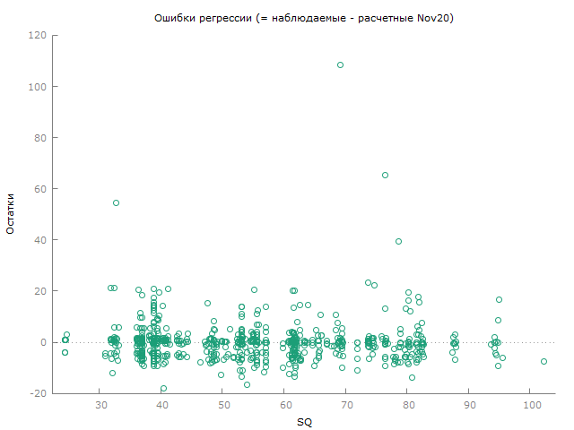

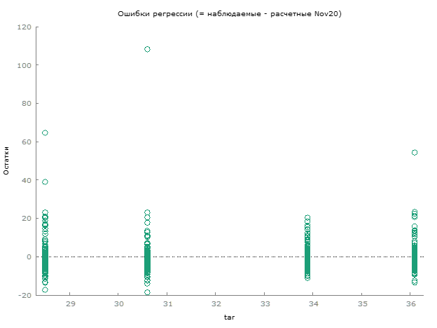

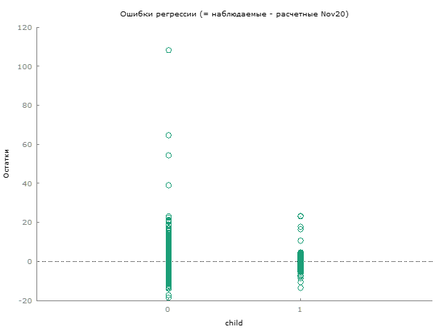

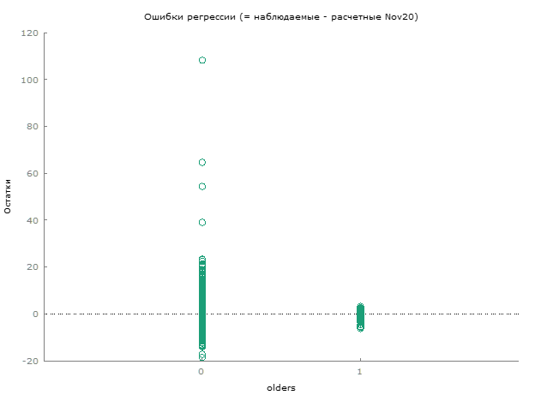

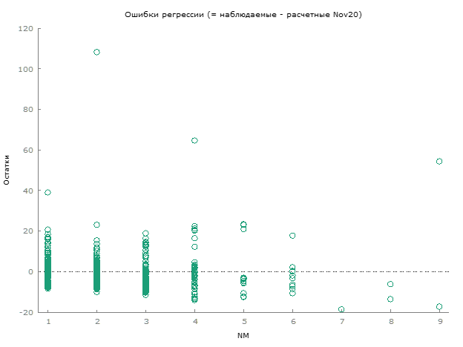

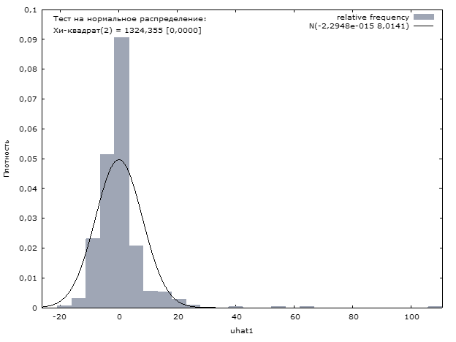

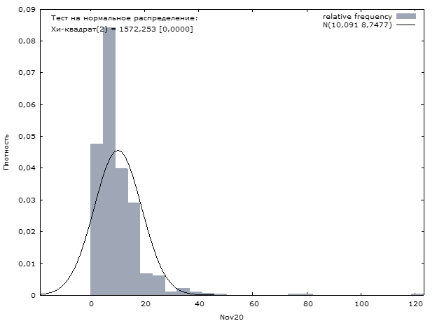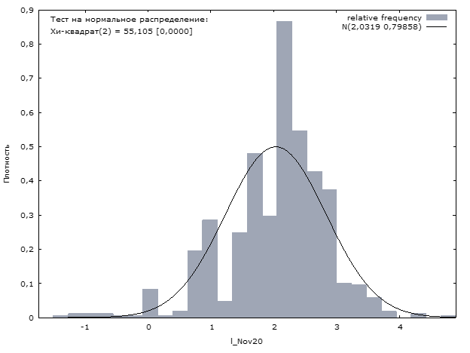

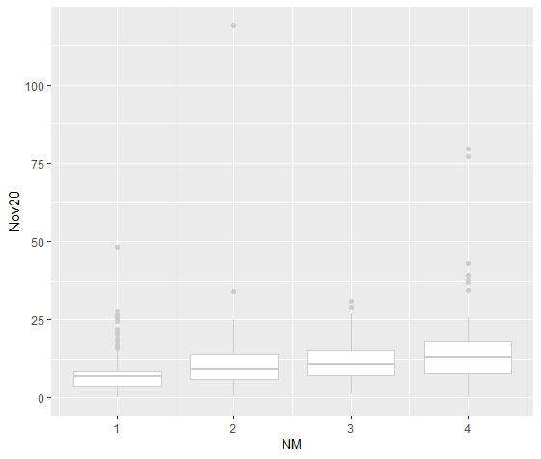

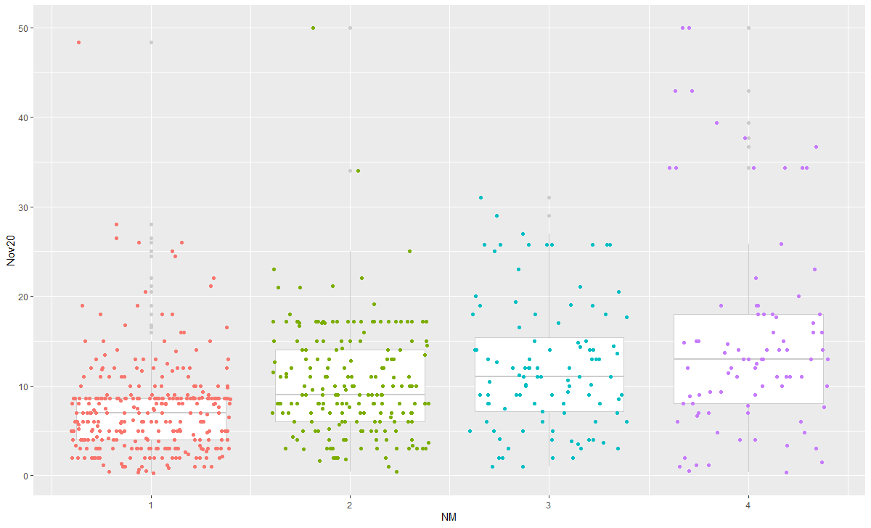

|  |  |  |  |
| --- | --- | --- | --- |
| **Table 2** Size and Water Consumption | |  |  |
| Size of household | Total consumption | Per capita consumption | Variation in per capita consumption |
| NM=1 | 7.478245 | 7.478245 | - |
| NM=2 | 10.25418 | 5.127089 | -2.351156 |
| NM=3 | 12.21395 | 4.071317 | -1.055772 |
| NM=4 | 15.42699 | 3.856749 | -0.214568 |
| NM>=5 | 17.16167 | 3.419519 | -0.424416 |



BIBLIOGRAPHY

Aitken, Campbell K., Thomas A. Mcmahon, Alexander J. Wearing, and Brian L. Finlayson. 1994. ‘Residential Water Use: Predicting and Reducing Consumption1’. *Journal of Applied Social Psychology* 24 (2): 136–58. https://doi.org/10.1111/j.1559-1816.1994.tb00562.x.

Arbués, Fernando, and Inmaculada Villanúa. 2006. ‘Potential for Pricing Policies in Water Resource Management: Estimation of Urban Residential Water Demand in Zaragoza, Spain’. *Urban Studies* 43 (13): 2421–42.

Arbués, Fernando, Inmaculada Villanúa, and Ramón Barberán. 2010. ‘Household Size and Residential Water Demand: An Empirical Approach’. *Australian Journal of Agricultural and Resource Economics* 54 (1): 61–80. https://doi.org/10.1111/j.1467-8489.2009.00479.x.

Bernedo, María, Paul J. Ferraro, and Michael Price. 2014. ‘The Persistent Impacts of Norm-Based Messaging and Their Implications for Water Conservation’. *Journal of Consumer Policy* 37 (3): 437–52. https://doi.org/10.1007/s10603-014-9266-0.

Cheesman, Jeremy, Jeff Bennett, and Tran Vo Hung Son. 2008. ‘Estimating Household Water Demand Using Revealed and Contingent Behaviors: Evidence from Vietnam: HOUSEHOLD WATER DEMAND IN VIETNAM’. *Water Resources Research* 44 (11). https://doi.org/10.1029/2007WR006265.

Corral-Verdugo, Victor, Robert Bechtel, and Blanca Fraijo-Sing. 2003. ‘Environmental Beliefs and Water Conservation: An Empirical Study’. *Journal of Environmental Psychology* 23 (September): 247–57. https://doi.org/10.1016/S0272-4944(02)00086-5.

Corral-Verdugo, Víctor, and Martha Frías-Armenta. 2006. ‘Personal Normative Beliefs, Antisocial Behavior, and Residential Water Conservation’. *Environment and Behavior* 38 (3): 406–21. https://doi.org/10.1177/0013916505282272.

Dandy, Graeme, Tin Nguyen, and Carolyn Davies. 1997. ‘Estimating Residential Water Demand in the Presence of Free Allowances’. *Land Economics* 73 (1): 125. https://doi.org/10.2307/3147082.

Danilov-Danil’yan, V. I., and K. S. Losev. 2006. ‘Potreblenie Vody: Ekologicheskii, Ekonomicheskii, Sotsial’nyi i Politicheskii Aspekty (Water Consumption: Environmental, Economic, Social, and Political Aspects)’. *Moscow: Nauka* 36 (2).

European Council, European parlament. 2000. ‘Directive 2008/94/EC of the European Parliament and of the Council of 22 October 2008’. London: European commission. https://doi.org/10.1007/978-1-137-54482-7_44.

Ferraro, Paul J, Juan Jose Miranda, and Michael K Price. 2011. ‘The Persistence of Treatment Effects with Norm-Based Policy Instruments: Evidence from a Randomized Environmental Policy Experiment’. *American Economic Review* 101 (3): 318–22. https://doi.org/10.1257/aer.101.3.318.

Gleerup, Maria, Anders Larsen, Søren Leth-Petersen, and Mikael Togeby. 2010. ‘The Effect of Feedback by Text Message (SMS) and Email on Household Electricity Consumption: Experimental Evidence’. *The Energy Journal* 31 (3): 113–32.

Graymore, Michelle L.M., and Anne M. Wallis. 2010. ‘Water Savings or Water Efficiency? Water-Use Attitudes and Behaviour in Rural and Regional Areas’. *International Journal of Sustainable Development & World Ecology* 17 (1): 84–93. https://doi.org/10.1080/13504500903497249.

Harland, Paul, Henk Staats, and Henk A. M. Wilke. 1999. ‘Explaining Proenvironmental Intention and Behavior by Personal Norms and the Theory of Planned Behavior1’. *Journal of Applied Social Psychology* 29 (12): 2505–28. https://doi.org/10.1111/j.1559-1816.1999.tb00123.x.

Haynes, Laura C., Donald P. Green, Rory Gallagher, Peter John, and David J. Torgerson. 2013. ‘Collection of Delinquent Fines: An Adaptive Randomized Trial to Assess the Effectiveness of Alternative Text Messages’. *Journal of Policy Analysis and Management* 32 (4): 718–30.

Jorgensen, Bradley S., John F. Martin, Meryl W. Pearce, and Eileen M. Willis. 2014. ‘Predicting Household Water Consumption With Individual-Level Variables’. *Environment and Behavior* 46 (7): 872–97. https://doi.org/10.1177/0013916513482462.

Kahneman, Daniel. 2013. *Thinking, Fast and Slow*. 1st pbk. ed. New York: Farrar, Straus and Giroux.

Lim, Guay C., Chew Lian Chua, Edda Claus, and Viet H. Nguyen. 2012. ‘Review of the Australian Economy 2011-12: A Case of Déjà Vu’. *Australian Economic Review* 45 (1): 1–13. https://doi.org/10.1111/j.1467-8462.2011.00672.x.

Lindenberg, Siegwart, and Linda Steg. 2007. ‘Normative, Gain and Hedonic Goal Frames Guiding Environmental Behavior’. *Journal of Social Issues* 63 (1): 117–37. https://doi.org/10.1111/j.1540-4560.2007.00499.x.

Martins, Rita, and Adelino Fortunato. 2007. ‘Residential Water Demand under Block Rates – a Portuguese Case Study’. *Water Policy* 9 (2): 217–30. https://doi.org/10.2166/wp.2007.004.

Matsukawa, Isamu. 2004. ‘The Effects of Information on Residential Demand for Electricity’. *The Energy Journal* 25 (1). https://doi.org/10.5547/ISSN0195-6574-EJ-VOL25-NO1-2.NADEL.

Mazzanti, Massimiliano, and Anna Montini. 2005. ‘The Determinants of Residential Water Demand Empirical Evidence for a Panel of Italian Municipalities’. *SSRN Electronic Journal*. https://doi.org/10.2139/ssrn.670234.

Nauges, Céline, and Alban Thomas. 2003. ‘Long-Run Study of Residential Water Consumption’. *Environmental and Resource Economics* 26 (1): 25–43. https://doi.org/10.1023/A:1025673318692.

Nolan, Jessica M., P. Wesley Schultz, Robert B. Cialdini, Noah J. Goldstein, and Vladas Griskevicius. 2008. ‘Normative Social Influence Is Underdetected’. *Personality and Social Psychology Bulletin* 34 (7): 913–23. https://doi.org/10.1177/0146167208316691.

Ojeda-Benítez, Sara, Carolina Armijo-de Vega, and Ma Ysabel Marquez-Montenegro. 2008. ‘Household Solid Waste Characterization by Family Socioeconomic Profile as Unit of Analysis’. *Resources, Conservation and Recycling* 52 (7): 992–99. https://doi.org/10.1016/j.resconrec.2008.03.004.

Rabinovich, Anna, Thomas A. Morton, Tom Postmes, and Bas Verplanken. 2009. ‘Think Global, Act Local: The Effect of Goal and Mindset Specificity on Willingness to Donate to an Environmental Organization’. *Journal of Environmental Psychology* 29 (4): 391–99. https://doi.org/10.1016/j.jenvp.2009.09.004.

Reis, Ricardo. 2006. ‘Inattentive Consumers’. *Journal of Monetary Economics* 53 (8): 1761–1800.

Richetin, Juliette, Marco Perugini, Denny Mondini, and Robert Hurling. 2014. ‘Conserving Water While Washing Hands: The Immediate and Durable Impacts of Descriptive Norms’. *Environment and Behavior* 48 (2): 343–64. https://doi.org/10.1177/0013916514543683.

Schleich, Joachim, and Thomas Hillenbrand. 2009. ‘Determinants of Residential Water Demand in Germany’. *Ecological Economics* 68 (6): 1756–69. https://doi.org/10.1016/j.ecolecon.2008.11.012.

Starr, Joyce R. 1991. ‘Water Wars’. *Foreign Policy*, no. 82: 17–36. https://doi.org/10.2307/1148639.

Syme, Geoffrey J., Blair E. Nancarrow, and Clive Seligman. 2000. ‘The Evaluation of Information Campaigns to Promote Voluntary Household Water Conservation’. *Evaluation Review* 24 (6): 539–78. https://doi.org/10.1177/0193841X0002400601.

UNESCO, ed. 2003. *Water for People, Water for Life*. The United Nations World Water Development Report, [1].2003. New York: UNESCO [u.a.].

West, Sarah E, and Roberton C Williams. 2005. ‘The Cost of Reducing Gasoline Consumption’. *American Economic Review* 95 (2): 294–99. https://doi.org/10.1257/000282805774669673.

World Health Organization, and UN-Water. 2014. *UN-Water Global Analysis and Assessment of Sanitation and Drinking-Water (GLAAS) 2014 Report: Investing in Water and Sanitation: Increasing Access, Reducing Inequalities*. Geneva: World Health Organization. https://apps.who.int/iris/handle/10665/139735.